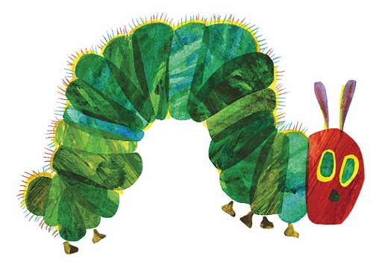 | caterpillar
 | apple
 | pear
 | plum
 | strawberry
 | orange
 | leaf
 | cocoon
 | butterfly
